IT24103056

LABSHEET -05

Q1.

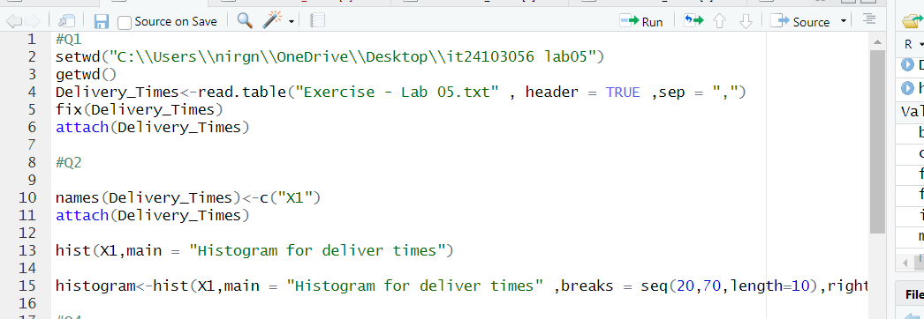

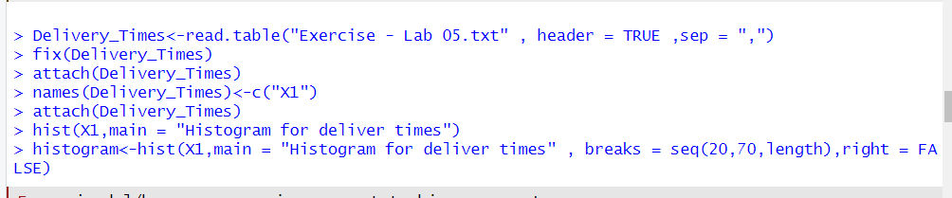

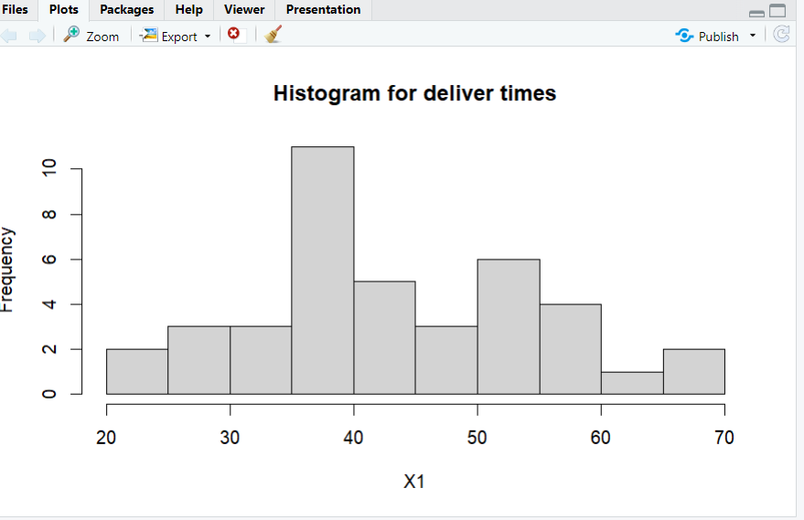

Q3.Apporoximately symmetric and bell shaped.

Q4.

